Open the TI-Nspire document Interrogating_Data.tns.  Seventh graders at Mt. Ella Junior High have been selected to participate in a national study on mathematics education. Can evaluators predict the mean and median of the mathematics scores of all seventh grade students if they take samples of scores? | 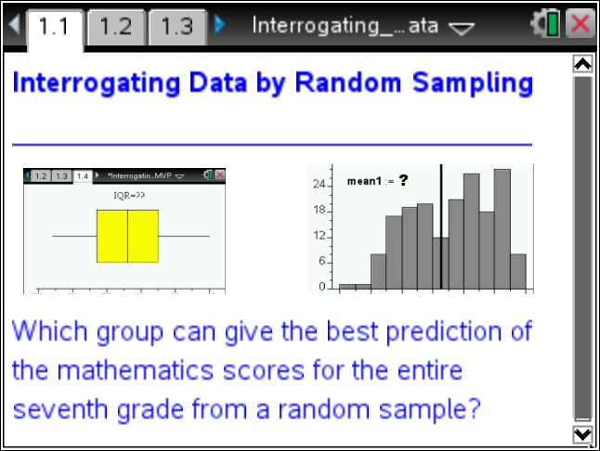

1. Why might one use a sample instead of collecting data from an entire population?

2. Why is it important to obtain a random sample from a population of interest?

Move to page 1.2. | Press / ¢ and / ¡ to navigate through the lesson.
3. You will generate three random samples from the data set provided. Sample 1 will be a random sample of 5 scores; Sample 2 will have 15 scores; and Sample 3 will have 30 scores.

Move to Page 1.3
To generate a random sample from the population, follow these steps:
- In Column A, named sample1, move the cursor to the gray formula row.
- Type =randsamp(population,______), entering your sample size after the comma, and press ·. You should see scores in that column.
- Repeat for Column B for sample2 and Column C for sample3.

4. a. What different types of data displays would be appropriate for samples from this data set?

b. What are some ways each of your samples could be summarized using a single number?

c. What are some ways of describing the spread or variability of each of your samples?

Move to page 1.4.

5. Create a box plot on this page following these steps:
- Dots for the data automatically appear. Move the cursor to the bottom of the screen, and select “Click to Add Variable.”
- Select variable sample1. A dot plot will automatically be created.
- To change the plot type, select MENU > Plot Type > Box Plot.
- Move the cursor onto the box plot (it will change to a hand), and press / b.
- Select Color ¢ Fill Color. Select the color you want to use for the plot.

6. To view all three box plots, select MENU > Plot Properties > Add X variable. Select sample2, and add color to the plot of Sample 2 using the instructions above. Repeat to create a box plot of sample3 on the same screen.

Move to page 1.5.

7. a. Create a histogram for Sample 1 by moving the cursor to the bottom of the screen and clicking “Click to Add Variable”.
- Select variable sample1, and you will see a dot plot.
- To change the plot type, select MENU > Plot Type > Histogram.

Move to page 1.6.

b. Create a histogram for Sample 2, choosing variable sample2 and following the directions above.

Move to page 1.7.

c. In the same way, create a histogram for Sample 3.

Move back to page 1.3.

8. Move to Column D and place the cursor in cell D2. To find the mean of Sample 1, type the following: =1.*mean(sample1), and press ·.
- Move to cell D4 and find the mean of Sample 2. Type =1.*mean(sample2), and press ·.
- Move to cell D6 and find the mean of Sample 3. Type =1.*mean(sample3), and press ·.

Mean Absolute Deviation
9. Move the cursor to the right to Column E, meandev1.
- In the gray formula cell, type = abs(sample1 - d2), and press ·.
- Move to the formula cell for Column F, meandev2, type = abs(sample2 - d4), and press ·.
- Move to the formula cell for Column G, meandev3, type = abs(sample3 - d6), and press ·.
- Next, move to cell H2, type =sum(meandev1)/5, and press ·. Move to cell H4, type =sum(meandev2)/15, and press ·. Move to cell H6, type =sum(meandev3)/30, and press ·.

a. Explain what the formula meandev1 = abs(sample1 - d2) calculates.

b. Why is it necessary to calculate the absolute value of each element in the column?

c. What is learned by calculating the Mean Absolute Deviation?

10. Fill in the table below, and use the information and the data displays for your random samples to make predictions about the measures of center and variability for the data from the entire population.

 | Data |  | Histograms | Box Plots
 | Mean | Mean Absolute Deviation | Symmetric, Skewed to left, Skewed to right, Holes, Clusters | Median | Interquartile Range (IQR) | Outliers
Sample1,
5 scores

Sample2,
15 scores

Sample3,
30 scores

a. My prediction is that the population mean = ______________; MAD = __________; the median = ______ and the IQR = ______________.

b. My reason(s) for this prediction:

c. Sketch a box plot for the population data based on the information above. Indicate the values of the 5 summary points.

11. Use the handheld to make a box plot of the data for the entire population, and then find the median and IQR for the entire data set.
- Press /~ > Add Data and Spreadsheet.
- Move the cursor to the bottom of the screen, click “Click to Add Variable,” and select the variable population.
- To change to a box plot, select MENU > Plot Type > Box Plot.
- Move the cursor onto the box plot, select / > MENU > Color > Fill Color. Select a color for the box plot

a. Hover over the median to see the value. Record the value. Median = _______.

b. Hover over Q3 and Q1 on the plot to see these values and calculate the IQR. Record the value. IQR = ______.

c. How do the median and IQR of the population compare with your predictions?

12. Use the handheld to make a histogram using all the data for the population and to find the mean and the mean absolute deviation for the population data set.
- Add a Data and Statistics page (Page 1.9).
- Move the cursor to the bottom of the screen, click “Click to Add Variable,” and select the variable population.
- To change to a histogram, select MENU > Plot Type > Histogram.

a. Add a line representing the mean, select MENU > Analyze > Plot Value. In the box that appears, type mean(population), and press ·. Record the value. Mean = _______.
Move back to page 1.3.

b. Calculate the Mean Absolute Deviation by moving the cursor to the gray formula row in Column I and typing =abs(population – “value of pop mean from part a”). Press ·.

Move to cell J2, and type =sum(meandevpop)/180. Press ·.
(Note: There are 180 grades in the population.)
c. What are the values of the mean and the Mean Absolute Deviation of the population? How do they compare with your predictions?

13. Name two examples of populations that would require sampling in order to study.

14. Why would sampling be necessary for your examples above?

15. Is one sample sufficient to draw inferences about a population? Why or why not?

16. Is the sample mean or the sample median a better predictor for the center of the population?

