In this activity, students will discuss and describe the center and spread of a univariate data set by way of a five number summary and visually by a box & whisker diagram. Students will then apply this knowledge to real life applications to enhance their ability to understand this math in statistical data analysis. | 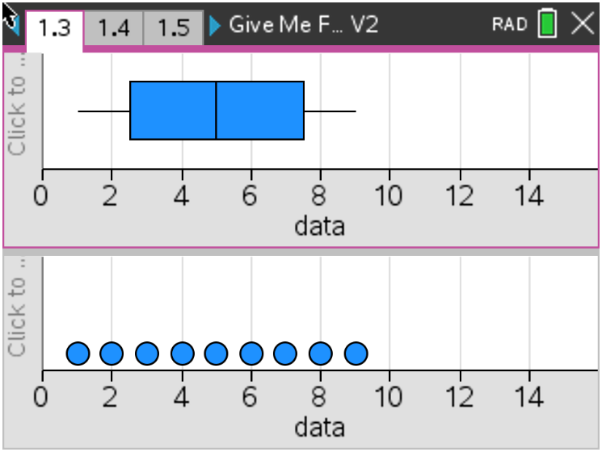
Introduction

A univariate set of data is a list of numbers that describes the different value of a variable characteristic across a range of different units. For example, if a study involved finding out the height of a range of people, each person whose height is measured is statistically considered to be a ‘unit’. Height is the characteristic that varies (variable) and the list of height measurements is called the data.
When describing a group of data, there are generally two main types of things to consider:
- Measure of center – this is a single value that could be used as a representative of the entire data set (e.g. mean, median, mode)
- Measure of spread – this is a number that indicates how spread out the data are (e.g. standard deviation, range, inter-quartile range)
Problem 1 – The Fantastic Five
A five number summary is a convenient way of describing a set of data as it provides us with information about both center and spread. Consider the set of data: {1, 2, 3, 4, 5, 6, 7, 8, 9}. We can see that the numbers are already ordered from lowest to highest.

1. Find the minimum value in the data set. We call this value MinX.

2. Find the maximum value in the data set. We call this value MaxX.

3. Find the middle value in the data set. We call this value MedianX.

4. Look at the numbers that are less than the Median, find the median of this set of numbers. Discuss with a classmate what the median would be if this data set was an even number of data and if this data set was an odd number of data. Find the name you would give this piece of data.

5. Look at the numbers that are less than the Median, find the median of this set of numbers. Discuss with a classmate what the median would be if this data set was an even number of data and if this data set was an odd number of data. Find the name you would give this piece of data.

6. You have found Q₁ and Q₃. Discuss with a classmate what Q₂ is.

The five numbers that are your answers to questions 1 to 5 are called the five number summary. Usually the five number summary is written in the order MinX, Q₁, Median, Q₃, MaxX. The median (Answer to question 3) is the measure of center. The other numbers provide indications of spread.

- MaxX minus MinX is the Range.
- Q₃ minus Q₁ is the Inter-Quartile Range (IQR).

7. Find the range for the data set {1, 2, 3, 4, 5, 6, 7, 8, 9}.

8. Find the Inter-Quartile Range for the data set {1, 2, 3, 4, 5, 6, 7, 8, 9}.

Problem 2 – Automatic Calculation of the Five Number Summary

Open the tns file: Give Me Five.tns

Observe the data set {1, 2, 3, 4, 5, 6, 7, 8, 9} on page 1.2.

The data values are entered into a Lists & Spreadsheets page under the column title of ‘data’. Summary statistics for the data have been calculated and displayed in the next two columns.

Page 1.3 provides a graphical representation of the data set. This type of graph is called a Box Plot or a Box & Whisker Diagram. A dot plot is included beneath the Box Plot.
If you scroll your calculator cursor over this graph, the five numbers of the five number summary will be revealed. Note that they are in line with corresponding numbers on the scale below.

Move the cursor over the top of the data point with the largest value in the dot plot (9). Grab the point (click and hold) and move it to the right.

1. Explain why Q₁, the median and Q₃ do not change when the data point (9) is increased.

2. Explain what happens to the whisker when this data point is moved further and further away from the rest of the data. Find at what value, approximately, this significant change occurs.

Navigate to page 1.4. This is a Dynamic Notes page that is set up to show the range and the interquartile range of the data set from page 1.2.
It shows the five number summary as a set of 5 values in brackets { }.
The five values are also shown on separate lines below this.

Note that if you go back to page 1.2 and make changes to the data set, the Box Plot and the Dynamic Notes Five Number Summary will automatically change to reflect the new data set.

3. Navigate to page 1.2 and replace the data set {1, 2, 3, 4, 5, 6, 7, 8, 9} with
{9, 3, 8, 5, 7, 4, 1, 6, 2}. Discuss with and state the affects this may have on the Box Plot and statistics calculations. Explain why you think this is so.

4. Use the automatic calculator (Page 1.4) to compute the five number summary of the data set: {1, 2, 3, 4, 5, 6, 7, 8, 9, 10}. Validate the five number summary by hand.

5. Use your answer to the previous question to find a data set that has a five number summary made up entirely of integers.

Problem 3 – Consideration of shape and skew
So far the data sets we have considered have been symmetrical. That is, the Box Plot is geometrically symmetrical and has a vertical line of symmetry at the median. This means that Q₁ is as far below the median as Q₃ is above it and MinX is as far below the median as MaxX is above it. You may also have noticed that the mean value (indicated in column C of 1.2) is always the same as the median.

If necessary, adjust the data set on Page 1.2 so that it is equal to: {1, 2, 3, 4, 5, 6, 7, 8, 9}. Note that the median value is 5, as also is the mean. Now move to Page 1.3 and observe the Box Plot for these data, it is perfectly symmetrical. Click on the MaxX value at the end of the right-hand whisker. The MaxX value (9) will be highlighted and also the value (8). |  | If necessary, adjust the data set on Page 1.2 so that it is equal to: {1, 2, 3, 4, 5, 6, 7, 8, 9}. Note that the median value is 5, as also is the mean. Now move to Page 1.3 and observe the Box Plot for these data, it is perfectly symmetrical. Click on the MaxX value at the end of the right-hand whisker. The MaxX value (9) will be highlighted and also the value (8). |  | If necessary, adjust the data set on Page 1.2 so that it is equal to: {1, 2, 3, 4, 5, 6, 7, 8, 9}. Note that the median value is 5, as also is the mean. Now move to Page 1.3 and observe the Box Plot for these data, it is perfectly symmetrical. Click on the MaxX value at the end of the right-hand whisker. The MaxX value (9) will be highlighted and also the value (8).
Drag the whisker to the right so that MaxX is at about 12.
Q₃ will move up to about 9. Notice that the distribution is now no longer symmetrical. The part of the box that is between the median and Q₃ is bigger than the part between the median and Q₁. The distribution is now said to be positively skewed or skewed right.
Notice also that, although the median is still 5, the mean value has moved up to about 5.6. Restore the original data set and repeat this process to show a negative skew or skew left.

1. Match each of the following Box Plots with its matching description of symmetry and comment about measure of center.

Box Plot Description of Shape Comment on measure of center
Symmetrical | Mean > Median
Positively skewed |  | Mean < Median
Negatively skewed | Mean = Median

Outliers and Fences
Restore your data list to the set: {1, 2, 3, 4, 5, 6, 7, 8, 9}.

Now add in a 10th value to the list. Make this value 16. Observe the corresponding Box Plot. Notice that the value 16 doesn’t appear within the main box or whisker, but is shown as a dot on its own. This is because the score 16 is so far away from the other data points that it is considered to be an outlier.  Experiment by replacing the 16 with values that are closer to the original data set. Try replacing it with 14, 13, 12, 11, 10. | 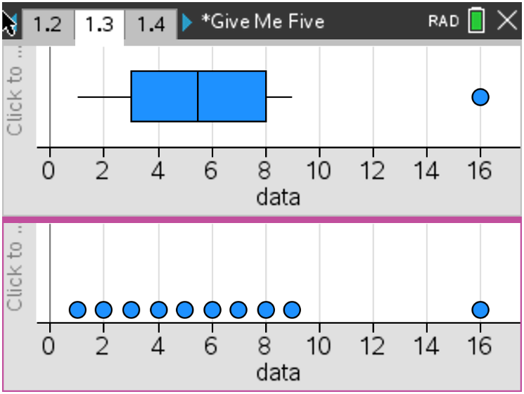
A numerical value that determines the threshold for outliers can be computed and is referred to as the upper fence value where the outlier is above the median and lower fence value where the outlier is below the median. The upper and lower fences are defined by using the Inter-Quartile Range (IQR).

Upper Fence Value = Q3 + 1.5 x IQR
Lower Fence Value = Q1 - 1.5 x IQR

Example
If you have a set of 8 scores {1, 2, 3, 4, 5, 6, 7, 8}, such that Q₁ = 2.5, Q₃ = 6.5 and the IQR = 4.

Upper fence = 6.5 + 1.5 x 4
= 12.5

Lower Fence = 2.5 – 1.5 x 4
= -3.5

Page 1.5 is a Dynamic Notes page that shows the calculation of Lower and Upper Fences.  Page 1.6 Shows the Box Plot again, this time with the fences displayed as vertical lines.  Drag the outlier to the fence and observe what happens. | 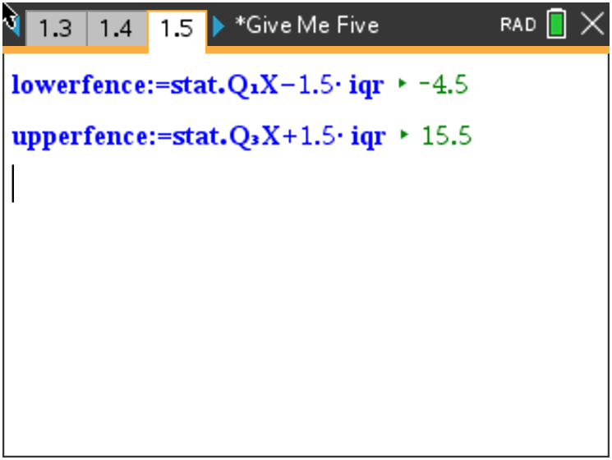  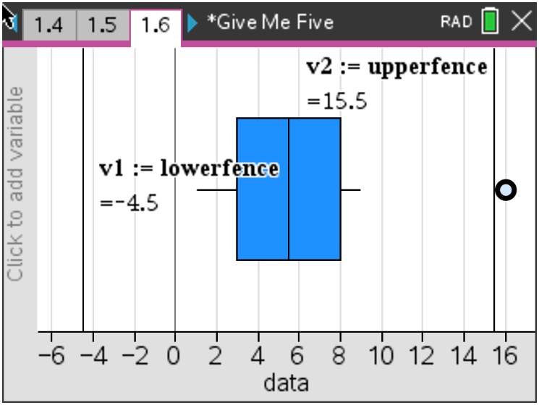

2. Discuss with a classmate and explain how it is possible to calculate the IQR whilst a single outlier is changed.

Further IB Application

The scores of a mathematics test given to period 1 are shown below.

40, 62, 65, 71, 73, 74, 75, 77, 80, 90, 92, 93, 96, 97, 98

For the data, the lower quartile is 71 and the upper quartile is 93.

(a) Show that the test score of 40 would not be considered an outlier.

The same mathematics test was given to period 2 and the box and whisker diagram showing their scores (scores2) and comparing them to the scores of period 1 (scores) are below.

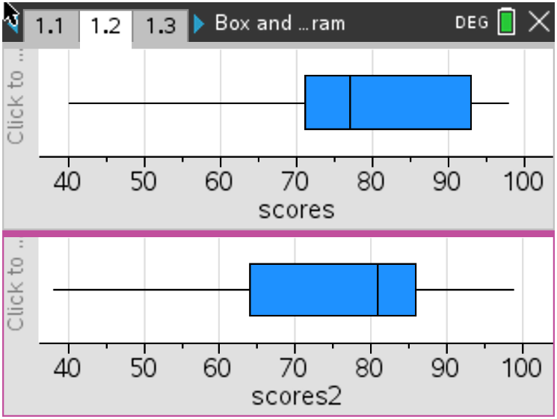

A fellow mathematics teacher looks at the box and whisker diagrams and believes that period 2 performed better than period 1.

(b) Using the diagrams above, state one reason that may support the mathematics teacher’s opinion and one reason that may counter it.

