Activity Overview
This activity will introduce the Calculator-Based Ranger™ 2 motion sensor and the Vernier EasyData® app. You will collect data and analyze both linear and non-linear data.
Materials
- TI-84 Plus CE with Vernier EasyData® app or TI-SmartView™ CE emulator software.
- CBR™ 2 motion sensor
- USB Connection Cable for CBR 2 motion sensor
- Note: To plug the CBR 2 into the computer, a mini-standard USB adaptor is needed.

Step 1:  Connect the CBR 2 to the TI-84 Plus CE with the USB cable. If the EasyData app does not open, press Œ and select EasyData. The CBR 2 will begin collecting distance data, the distance of the closest object from the CBR 2. In the EasyData app, the tabs at the bottom of the screen indicate the menus that can be accessed by pressing the calculator keys directly below the tabs. | 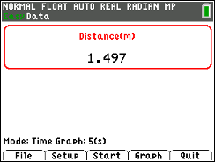
Step 2:
Work in groups of two. One person will operate the calculator and also point the CBR 2 toward the torso of the other person, the “walker.” The walker should be standing approximately two meters from the motion sensor. The walker will walk slowly toward the motion sensor at a constant rate for five seconds.
Step 3:  Before collecting data, make a prediction of what the graph of distance versus time should look like. Sketch your prediction on the graph to the right. | 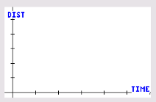
Step 4:
When ready, the calculator operator should press the q key for Start. Remember, the walker should walk SLOWLY toward the CBR 2 at a constant rate for 5 seconds.
Step 5:
A graph of distance versus time is displayed.
Repeat as necessary until you generate a graph for distance versus time that is approximately linear. To generate a new graph, press s for Main, and then press q for Start. Press s to select OK to overwrite the latest run.
How does the graph compare with your prediction?
Step 6:
Sketch the actual graph of your distance versus time graph on the graph to the right.
Step 7:
Manual Analysis of Data
The position of the walker at any time t is the walker’s distance from the CBR 2.
Include appropriate units in your answers to these questions.
- What does the position at time t = 0 seconds represent?

- What was the position of the walker at time t = 0 seconds? At time t = 5 seconds?

- How did the position of the walker change over the five seconds?

- The slope (change in position divided by change in time) is the average velocity of the walker during the five second walk. Why should the velocity be negative for this walk?

- Show your work to calculate the slope.

- Write an equation in the form y = m*x + b, where y is the position at time x, m is the slope (average velocity), and b is the initial position.
Linear Regression with the EasyData app  Step 8:  An analysis of the data with a linear regression curve can be performed within the EasyData app.  Press q for Anlyz, and select Linear Fit. | 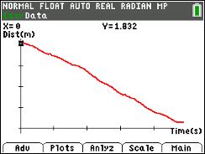  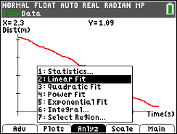
This will give the Curve Fit Coefficients for the linear regression model. Record the values for a and b below.  a =  b =  How do the values of a and b compare with the values you found in Step 7?  Step 9:  Press s for OK to display the graphical results of the regression computation. | 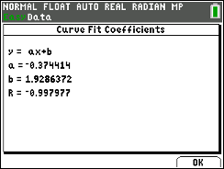  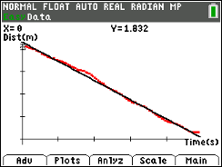
Explorations
- As you might have gathered from previous walks, the CBR 2 collects data by measuring how far an object is located from the sensor. In this first exploration, you will walk in front of the CBR 2 to collect a set of data which appears linear and has a positive slope. Before collecting data, sketch a prediction of this distance versus time graph on the graph at the right. After walking, describe the connections between the slope and y-intercept and the physical actions.
- By walking in front of the CBR 2, collect a set of data that represents a piecewise function with two parts, both of which are linear. One part should have a slope that is approximately zero.
Before collecting data, sketch a prediction of this distance versus time graph on the graph at the right.
After walking, describe the connections between the slope and y-intercept and the physical actions.

- The distance versus time graphs below are not linear; the slope (velocity) is not constant.
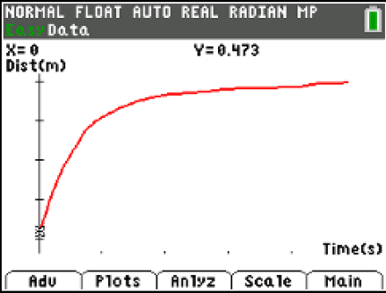
For each of these graphs, write a description for a walk that would produce the graph. Be sure to use language that describes the physical actions taken during the walk. Then, walk in front of the CBR 2 to create the graphs.
a.

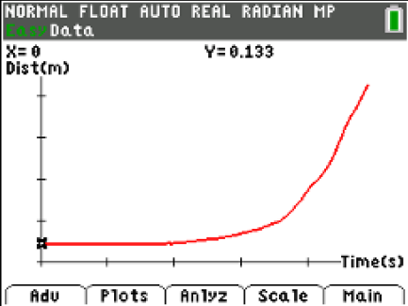
b.

