Overview

In this activity, you will create histograms and normal probability plots (NPP) to determine whether data sets are approximately normal.

Materials

• TI-Nspire™ handheld or Computer Software
- Normal_Probability_Plot_Create.tns

Note: The .tns file has pages already inserted because Page 1.9 contains information used in the activity Normal_Probability_Plot.  Step 1: Preparing the document  1. Open the document Normal_Probability_Plot_Create.tns by clicking on c > My Documents. Scroll down to choose Normal_Probability_Plot_Create and press ·.  2. Select MENU > Add Notes.  3. Type Normal Probability Plot.  Note: To obtain capital letters, press the g key, then the letter. | 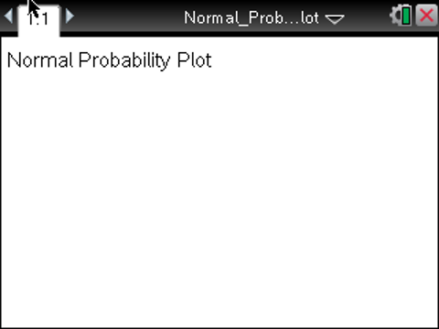
4. Press ~ > File > Save As … and type Normal_Probability_Plot. Then e to ¾ , and press ·.

Note: To obtain the underscore, press / _.

5. To go to the next page, press / > ¢ . Select MENU > Add Lists & Spreadsheet.

The following data were taken from a random sample of high school males.

Survey data from random sample of males
Height (in) | 73 | 74 | 71 | 67 | 69 | 71 | 72 | 70 | 69 | 72 | 71 | 69 | 71
Handspan (cm) | 20.5 | 20.5 | 18.75 | 20 | 19.5 | 20.5 | 20.25 | 20.5 | 17 | 20.5 | 20.5 | 16 | 18
Shoe Size (cm) | 32 | 30 | 31 | 29.5 | 31 | 29 | 39 | 32.5 | 31 | 32 | 30 | 30.5 | 31

6. Use the scroll bar on the right to move to the top of the spreadsheet, and then move the cursor to the top of Column A. Type height to label Column A, and press ·. Fill in the data for the shoe sizes. Move the cursor to the top of Column B, type handspan to label Column B, and press ·. Fill in the data for the handspans. Move the cursor to the top of Column C, type shoe to label Column C, and press ·. Fill in the data for the heights.  Note: To save your document, press / ». | 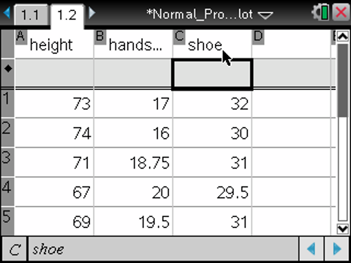
Step 2: Creating a histogram  Note: Statistics graphing is done through the Data & Statistics application.  7. To go to the next page, press / > ¢ . Select MENU > Add Data & Statistics.  8. Create a histogram for the heights.  Note: If you do not know how to create a histogram, reference the Statistics Nspired activity Histograms_Create. | 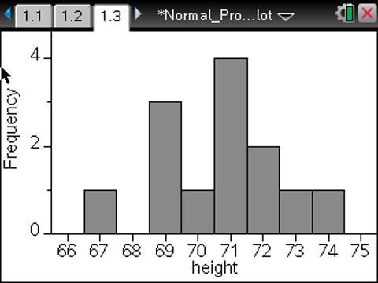
Step 3: Creating a normal probability plot (NPP)  9. To go to the next page, press / > ¢ . Select MENU > Add Data & Statistics.  10. Move the cursor to the location at the bottom of the page that says “click to add variable,” and press x. Select “shoe.” The screen will display a dot plot of the heights.  11. To create a normal probability plot, select MENU > Plot Type > Normal Probability Plot. | 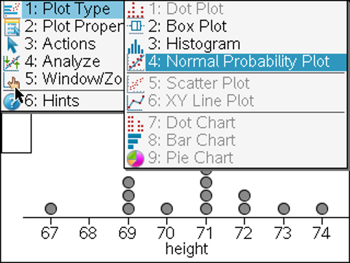
12. Repeat steps 6 through 10 to create a histogram and normal probability plot for “handspan” and “shoe.”  When finished, Page 1.5 displays the histogram for “handspan”, Page 1.6 displays the normal probability plot for “handspan”, Page 1.7 displays the histogram for “shoe”, Page 1.8 displays the normal probability plot for “shoe”, and Page 1.9 has the information about the weights of the sample of males preloaded from the original file you opened. Follow the directions on the activity sheet to investigate the plots on Page 1.9. | 