Activity Overview  In this activity, you will prepare a document that will allow you to capture data to explore the relationship between the circumference and diameter of a circle.  Materials  Technology needed (TI-Nspire™ handheld, computer software) | 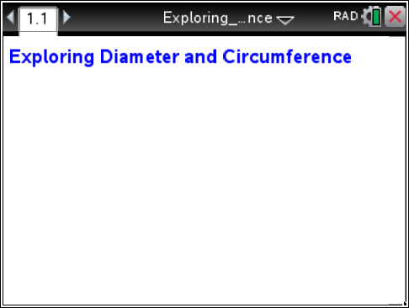

Part 1 Preparing the document
- Open a new document by clicking on c > New Document > Add Notes.
- Type Exploring Diameter and Circumference.
Notes: To obtain capital letters, press the g key, then the letter. To change the text format or color, first select the text by holding down the shift key and pressing the right or left arrow key on the
Touchpad. Then, press Menu > Format and select Format Text or Text Color.
- Press ~ > File > Save.
Type Exploring_Diameter_and_Circumference.
Tab to ¾ and press ·.
Note: To obtain the underscore on a handheld, press / _.
- To add a new page, press Doc > Insert > Page > Add Geometry.
Shortcut: Press / ~ > Add Geometry.
- Select Menu > Settings. Select “Fix 1” for display digits. Tab to Graphing Angle. Select Degree. Tab to Geometry Angle. Select Degree. Then press e to move from one field to the next and press x to uncheck each of the boxes. Tab to OK and press x or ·. | 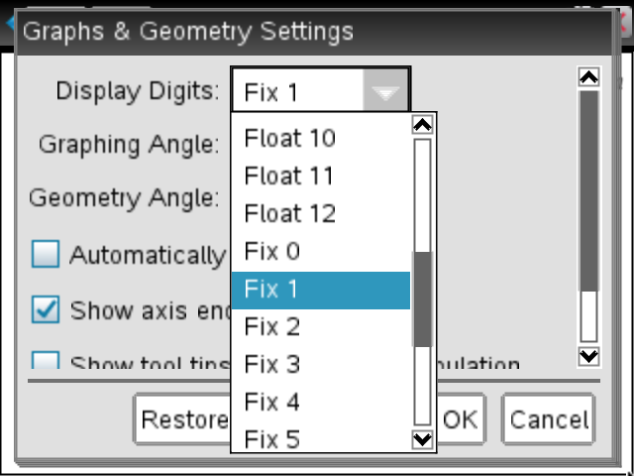  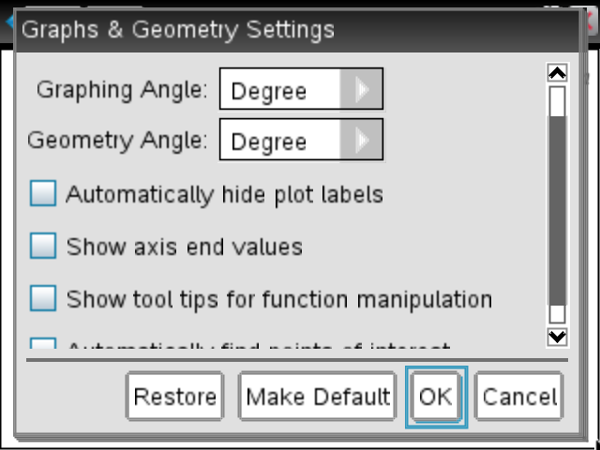
Part 2 Making a segment  - Select Menu > Points & Lines > Segment.  - Move the cursor to the left edge of the window and press x to create an endpoint of the segment.  - Move to the right and press x to create the other endpoint of the segment.  - Press d to exit the Segment tool. | 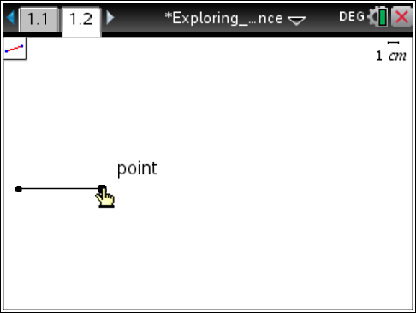
Part 3 Constructing a midpoint  - Select Menu > Construction > Midpoint.  - Move the cursor near the segment until you see a hand ø and the word segment. Press x.  - Press d to exit the Midpoint tool.  Note: A midpoint can also be constructed by pressing x or · on each endpoint. | 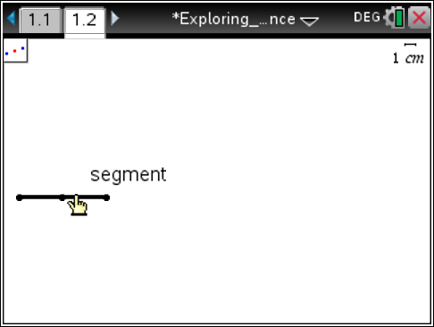
Part 4 Drawing a circle  - Press Menu > Shapes > Circle.  - Move to the midpoint of the segment and press x to select the point as the center of the circle.  - Move to an endpoint of the line segment and press x to indicate the radius point of the circle.  - Press d to exit the Circle tool. | 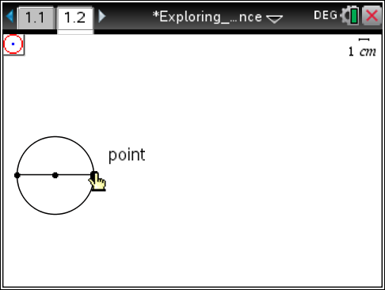
Part 5 Measuring a circle and its diameter  - Press Menu > Measurement > Length.  - Move the cursor over the circle until it is selected (it will be bold and the word circle appears). Press x to obtain the circumference. | 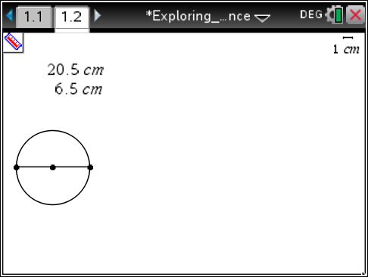
- Move the measurement to the top left of the screen and press x to place the measurement.
- Move the cursor over the segment until the segment is selected (it will be bold and the word segment appears). Press x to obtain the length of the diameter.
- Move the diameter value below the circumference measurement and press x.
- Press d to exit the Measurement tool.
Part 6 Storing values into variables  - Select the measurement for the circumference by clicking on it. A blue box will appear. Then press h and select Store Var.  - Type Circumference in place of the word var. Press ·. | 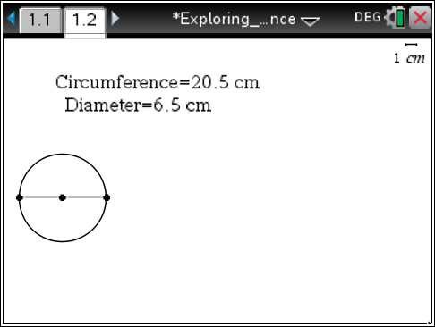
- Repeat this process to store the diameter value as Diameter.
Note: You may need to grab and move these values to the left part of the screen so that they can be read more easily.
Part 7 Using Lists & Spreadsheet  - Press ~ > Page Layout > Select Layout > Layout 2 to split the screen vertically.  - Select the application on the right hand side of the screen and press Add Lists & Spreadsheet.  Note: On the handheld, press /e, to switch applications, then press Menu > Add Lists & Spreadsheet. | 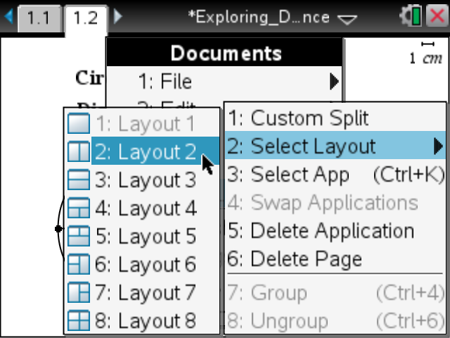
- Move to the top row above the formula row in Column A. Type d, for diameter. Press ·.  - Move to the top row above the formula row in Column B. Type c, for circumference. Press ·. | 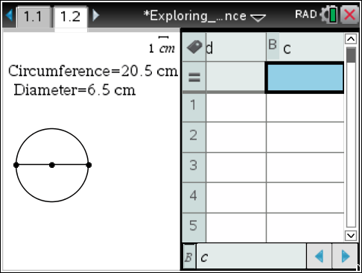
Part 8 Capturing Data  - Move to the formula row in Column A. Press Menu > Data > Data Capture > Manual.  - Type the word diameter in place of var and press ·.  Note: On the handheld press h, choose the variable diameter and press ·. | 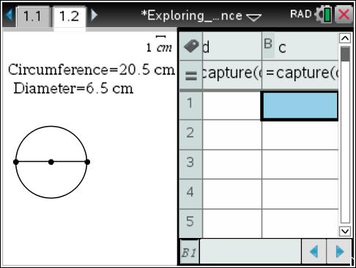
Part 9 Saving the document
- Move to the formula row in Column B. Press Menu > Data > Data Capture > Manual.
- Type the word circumference and press ·.
Note: On the handheld press h, choose the variable circumference and press ·.
- Press /S.
Note: To resize the data columns, place the cursor in the desired column, press / Menu > Resize > Resize Column Width. Then use the arrow keys and press · to save changes. In the accompanying activity, students will use Column C to explore relationships between diameter and circumference.

