Open the TI-Nspire document Complex_Number_Addition.tns.  In this activity, you will compute, visualize, and geometrically interpret the sum of two complex numbers such as and the sum  . | 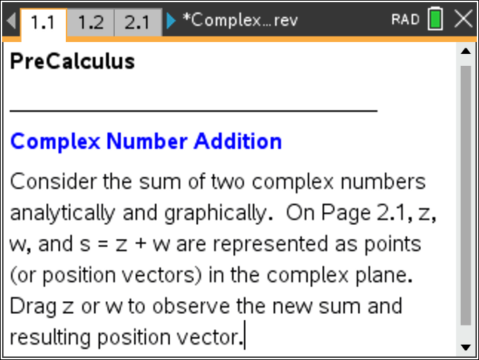

Move to page 1.2. | Press / ¢ and / ¡ to navigate through the lesson.
1. This Notes page contains three interactive Math Boxes for the complex numbers and the sum
a. Redefine and/or as necessary to complete the following two tables. To redefine or , edit the Math Box following the assignment characters (i.e., ).

b. Let and Explain in words how the complex numbers are added in terms of the real parts and the imaginary parts.

c. Let and Write the sum, symbolically in terms of the constants and

Move to page 2.1.

2. In the left panel, the complex numbers and are represented by points and position vectors in the plane. Point represents the sum of these two complex numbers. Drag either point or point , and the sum is automatically computed and updated. The right panel displays the actual values for and
a. Drag points and around the plane, and observe the results. Explain addition of complex numbers geometrically.

b. Position point in the second quadrant and point in the first quadrant. On the first set of axes below, sketch a figure representing the resulting sum On the second set of axes below, sketch a figure that you think might represent the difference Drag and position point to confirm your hypothesis. Hint:

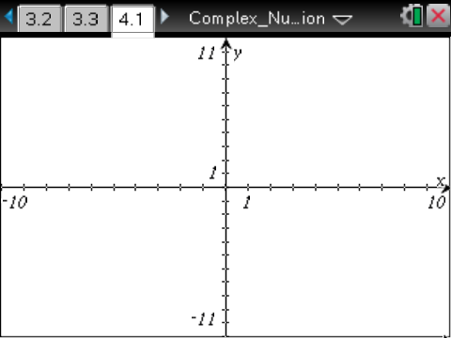

Move to page 3.1.

3. This page is a copy of Page 2.1 such that the real and imaginary parts of points and move only in increments of 0.5.
a. Drag and position point and/or point so the sum is 0—that is, and is represented by a point at the origin. Explain the relationship between points and

b. Drag and position point and point such that and Find the sum , and explain the relationship between the points representing and

c. The absolute value or magnitude of a complex number is Find the absolute value of and in part 3b, and explain how these three values are related.

The argument of a complex number is the angle, (in radians) formed between the positive real axis and the position vector representing See the figure to the right. The angle is positive if measured counterclockwise from the positive real axis. Recall,  d. Describe a method to find the argument of the complex number in part 3b above. Find the actual argument for and in part 3b. Explain how these three arguments are related. | 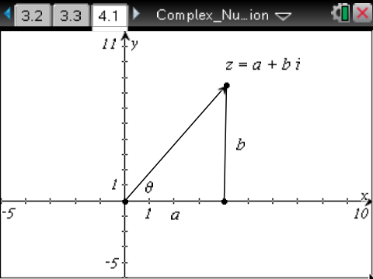
4. Drag and position point and point such that and
a. Find the sum , and explain the relationship between the points representing and

b. Find the absolute value of and in part 4a, and explain how these three values are related.

c. Find the argument of points and How are they related?

