Open the TI-Nspire™ document Sampling_Distributions.tns.  What is a sampling distribution of a statistic? A sampling distribution is the distribution of values of a given statistic based on all possible samples of a given size from a given population. In this activity, you will explore and describe the sampling distribution of the sample mean by creating and observing the means of a number of different samples from a given population. | 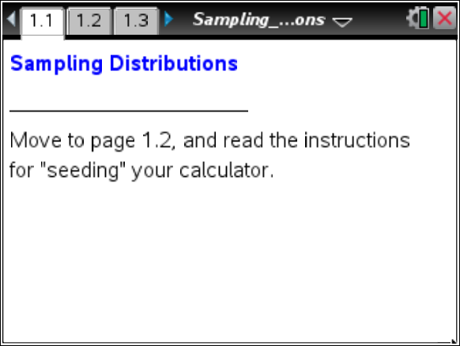

Move to page 1.2. | Press / ¢ and / ¡ to navigate through the lesson.
This activity involves generating a number of random samples from a population. In order to avoid having your results be identical to those of another student in the room, it is necessary to “seed” the random number generator. Read the instructions on page 1.2 for seeding your random number generator.

Move to page 2.1.

1. The graph on this page shows a normal distribution with mean 0 and standard deviation 1, representing a population of values. Recall the empirical rule and your knowledge of normal distributions. Predict the shape, center, and spread of a sample randomly selected from this population.

2. Each time you click the arrow (▲) labeled draw, you generate a random sample of size 10 from the given population. The elements of the sample will be displayed as points on the x-axis. Click to select the first sample. Look particularly at the center and spread of the values selected in the sample. Even though you have selected only 10 values from the population, do they seem to support your predictions in Question 1? Explain.

3. In addition to the 10 values that make up the sample, a vertical line is displayed on the plot. What do you think it represents? Explain your reasoning.

4. Think about the variability among the values that make up your sample and the variability among the vertical lines for several different samples.
a. Use draw to select another sample (still of size 10). Record the value of, and write a short description of how the individual values of your sample are distributed (look back at Question 2).

b. Repeat part a four more times. Describe how the values of vary compared to how the individual values in the samples vary.

c. Predict the center, spread, and shape of the distribution that would be formed by all values from a large number of samples. Explain.

Move to page 3.1.

5. The top work area on Page 3.1 shows the same population from Questions 1–4. An axis for a new dot plot has been added in the lower work area.
a. Click draw five times, and describe what seems to be happening in the dot plot.

b. What variable do you think is being plotted in the dot plot?

6. Click draw five more times to generate more values in the dot plot. Does the dot plot seem to confirm the predictions you made in Question 4 about the center, spread, and shape of the distributions of the values from a large number of samples? Explain.

7. You know several measures of spread. Think of one of those measures.
a. Without doing any actual calculations, estimate the value of that measure of spread, first for the set of individual values in the samples themselves, and then for the set of values in the dot plot in the lower screen on Page 3.1.

b. How do the measures of spread for the individual values and the sample means compare? Explain any differences you see.

Move to page 3.2.

8. The top work area on Page 3.2 is an exact copy of the lower work area on Page 3.1 with which you have been working. The lower work area displays the same data ( values from your samples) in a histogram.
a. Comment on which display seems better for seeing the overall shape of the distribution. Explain your reasoning.

Move back to page 3.1.

b. Each click of the draw arrow will generate ten more samples, and the means of those samples will be added to the plot in the lower work area. Click draw until you have about 100 samples, and then look at the graphs on page 3.2. Which graph type seems most appropriate for this larger simulation? Explain.

c. Describe the shape of the distribution of sample means. Estimate the mean and standard deviation of this distribution.

Move to page 3.3.

The plot on Page 3.3 is an exact copy of the histogram you examined on Page 3.2 but has an “adjustable” normal curve in the window. You can control the appearance of that curve by clicking on the arrows (▲ or ▼) to select a mean and standard deviation.
9. Use the arrows (▲ or ▼) to set the mean and standard deviation to match the estimates you made in Question 8c. Then, if necessary, re-adjust the values so that they fit your histogram as well as possible. Record your final values for mean and standard deviation. Comment on the accuracy of your predictions.

Move to page 4.1.

All of the students in grades 9-12 at a school measured the circumferences of their heads. The draw arrow will select different samples of size ten from the school population, and the mean circumference of the students' heads will be displayed in the lower plot.
10. a Use pages 4.1 and 4.2 to repeat the “sample-size-10” explorations you carried out in Questions 8 and 9 with this new population. Describe the sampling distribution of mean head circumferences for samples of size 10 taken from all grades 9-12 students in the school.

Note: Click the reset arrow on page 4.1 to erase an exploration using one sample size in order to begin a new exploration with another sample size.

b. The lower and upper arrows will generate samples of sizes other than 10 by changing the value of n. Repeat these explorations once more, this time using a different sample size. Comment on how changing the sample size affects the center, spread, and shape of the distribution of mean head circumference. Be as specific as possible, indicating what happens when the sample size increases and what happens when the sample size decreases.

11. Write a brief description to explain what you learned about a sampling distribution of sample means for someone who did not do this activity.

