Math Objectives  - Students will capture data to explore the relationship between the circumference and diameter of a circle.  - Students will use a scatter plot and a movable line to find an algebraic model for the relationship between the diameter and circumference of a circle.  Vocabulary  - circumference  - diameter  - radius  - slope  About the Lesson  - The time varies for the activity depending on whether the TI-Nspire document is provided for or created by the students. The instructions for creating the TI-Nspire document cover Parts 2-3 of this activity.  - Send the file Exploring_Diameter_and_Circumference.tns to student handheld devices. If you are planning for students to create the file, take time to follow the directions prior to facilitating the process with students.  - This activity is designed to be student-centered, with the teacher acting as a facilitator while students work cooperatively. The student worksheet is intended to guide students through the activity and provide a place to record their answers.  - Students will manipulate pre-made sketches, rather than create their own constructions. Therefore, a basic working knowledge of the handheld is sufficient.  TI-Nspire™ Navigator™ System  - Use Class Capture to observe students’ work as they proceed through the activity.  - Use Live Presenter to have a student illustrate how he/she used a certain tool. | 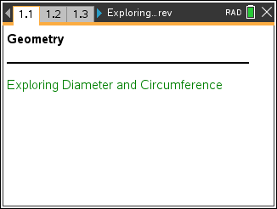  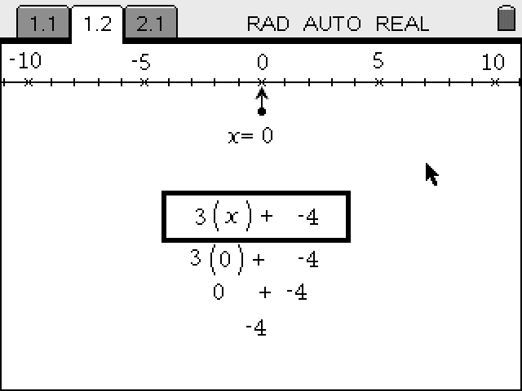  TI-Nspire™ Technology Skills:  - Download a TI-Nspire document  - Open a document  - Move between pages  - Grab and drag a point  Tech Tips:  - Make sure the font size on your TI-Nspire handheld is set to Medium.  Lesson Files:  Create Instructions  - Exploring_Diameter_and_  Circumference_Create.pdf  Student Activity  - Exploring_Diameter_and_  Circumference_Student.pdf  - Exploring_Diameter_and_  Circumference_Student.doc  TI-Nspire document  - Exploring_Diameter_and_  Circumference.tns

Discussion Points and Possible Answers

Tech Tip: If students experience difficulty dragging a point, check to make sure that they have moved the arrow until it becomes a hand (÷). Press / x to grab the point and close the hand ({).

Part 1 – Exploring the relationship between the diameter and circumference of a circle  Move to page 1.2.
  Press / ¢ and / ¡ to navigate through the lesson
- The London Eye is a large Ferris wheel in London. On page 1.2, you see a photograph of the London Eye with a circle constructed on it.  - Grab the open point at the end of the segment. Observe what happens when you drag that point onto the circle.  - Record your data in the table shown at the right.  Possible Answers are included in the table.  - Repeat Steps 2 and 3 for pages 1.3 and 1.4. You can calculate the value of C/d by pressing Menu > Actions > Calculate and then clicking on C/d and following the directions on the screen.  - Make a conjecture about your observations.  Sample Answer: All of the ratios are approximately the same. The circumference seems to be about three times the diameter. | 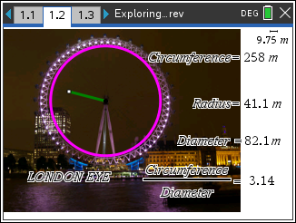
  Circumference | 395 m
  Diameter (d) | 126 m
  C/d | 3.14
  Circumference | 21.3 in
  Diameter | 6.79 in
  C/d | 3.13
  Circumference | 93.1 cm
  Diameter (d) | 29.5
  C/d | 3.16

Part 2 – Collecting data about the diameter and circumference of a circle  Move to page 2.1.  - On the left side of page 2.1, you see a circle, a diameter of the circle, and measurements for the circumference and diameter of the circle. The right side of page 2.1 shows a spreadsheet where data will be collected.  - Drag one of the points on the circle to change the diameter. What do you observe? |  | 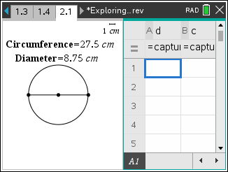  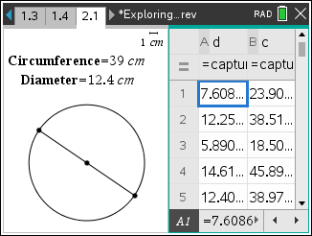
- To collect data, drag one of the points on the circle to change the diameter and press / and ^. This will populate row 1 in the spreadsheet for the diameter, d, and the circumference, c, values.
- Move the point again and press / and ^ to collect more data.
- Repeat above step until 5 rows of data are filled in the spreadsheet.
- Press / e to move to the spreadsheet on the right side of the screen. If necessary, move the cursor over the cells to read the values. Record your data in the table shown at the right.  Sample Answers: See table to the right.
   | d | c
  1 | 11.3 | 35.4
  2 | 8.9 | 28.1
  3 | 7.6 | 23.9
  4 | 6.2 | 19.4
  5 | 5.3 | 16.8
- a. What do you observe about the measurements of the diameter, d, and the circumference, c?

Sample Answer: Student should observe that the measurements of the circumference are about 3 times the measurements of the diameter.

b. Make a conjecture about the relationship between the variables c and d. (Use the words circumference and diameter in your conjecture.)

Sample Answer: “The circumference is about 3 times as large as the diameter.”
Teacher Tip: To resize the data columns, place the cursor in the desired column. Press / Menu > Resize > Resize Column Width. Then use the arrow keys to change the width of the column. Then press · to save changes.
- Move the cursor to the formula cell (= row) in Column C as shown in the figure at the right.  - Press = h, use £ or ¤ to highlight c and press · or x.  - Press p h, use £ or ¤ to highlight d and press · or x.  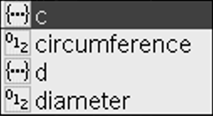  - Press · to calculate the values in Column C. | 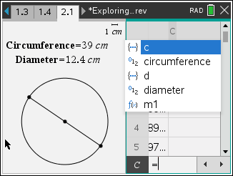  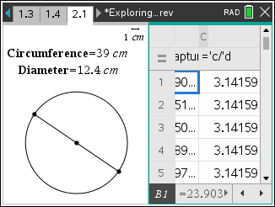
- a. What do you observe about the values in Column C?

Sample Answer: When the circumference is divided by the diameter you get a value that is
approximately 3.14.

b. How does this relate to your answer in question 2?

Sample Answer: This verifies my answer in question 2.

Long ago, mathematicians named the ratio of circumference to diameter with the Greek letter π (pi). Complete the statements below.
- If C is the circumference of a circle and d is the diameter of the circle, then there is a number π such that C = π × d. Also, in terms of the radius r of the circle, C = π × 2 × r.

Part 3 – Using a scatter plot (diameter vs. circumference) to explore the relationship  - Press / ~ > Add Data & Statistics.  - Press Menu > Plot Properties > Add X Variable.  - Select variable d to add the variable d on the horizontal axis.  - Press Menu > Plot Properties > Add Y Variable.  - Select variable c to add the variable c on the vertical axis. | 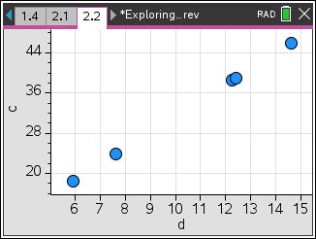
Teacher Tip: Shortcut - When you first add a Data & Statistics page, the words “Click to add a variable” appear at the bottom and on the left side. Click on the words at the bottom, your variable choices will appear. When you select a variable, the words on the left will disappear.

- In which quadrant do all points lie? Why?

Answer: The points lie in the first quadrant because you cannot have negative values for the measure of the diameter or the circumference of a circle.

- What type of equation would be a good fit for these data points?

Answer: a linear equation

- Consider the ordered pair (diameter, circumference). If you could have a circle with a diameter of 0 units, what would be the corresponding circumference? (0, ____)

Answer: If a circle had no diameter, it would also have no circumference. (0, 0)

- Press Menu > Window/Zoom > Window Settings. Enter the numbers as shown at the right. Then tab to OK and · to close the window.  Teacher Tip: Students’ data might not fall exactly in the given window settings. If not, they can select values that will better show their own data. | 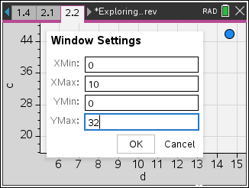
- Press Menu > Analyze > Add Movable Line.  - Position the cursor over the line until you see ö. Grab the line and move it up or down until it passes through the point (0, 0).  - Position the cursor over the line until you see é. Grab the line at the top right and rotate it until it closely matches the data.  - What is the equation of this line?  Sample Answer: m1(x) = 3.145*x+0.154 | 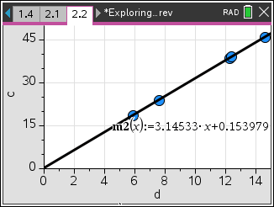
- a. What is the slope of this line?

Answer: The slope is about 3.14.

b. What does the slope represent?

Answer: The slope represents the change in the circumference (3.14 cm) for every 1 cm change in the diameter.

- If a circle has a diameter of 50 cm, what is its circumference? How do you know?

Answer: The circumference is about 157 cm because 50 × 3.14 = 157.

- If a circle has a circumference of 50 cm, what is its diameter? How do you know?

Answer: The diameter is about 15.9 cm because 50 ÷ 3.14 ≈ 15.9.

Wrap Up
Upon completion of the discussion, the teacher should ensure that students understand:
- How to capture data to explore the relationship between the circumference and diameter of a circle.
- How to use a scatter plot and a movable line to find an algebraic model for the relationship between the diameter and circumference of a circle.

