Open the TI-Nspire document Exploring_Power_Functions_2.tns.  This activity will explore the graphs, the end behavior, and key points for power functions with unit fractions and negative integers as exponents. | 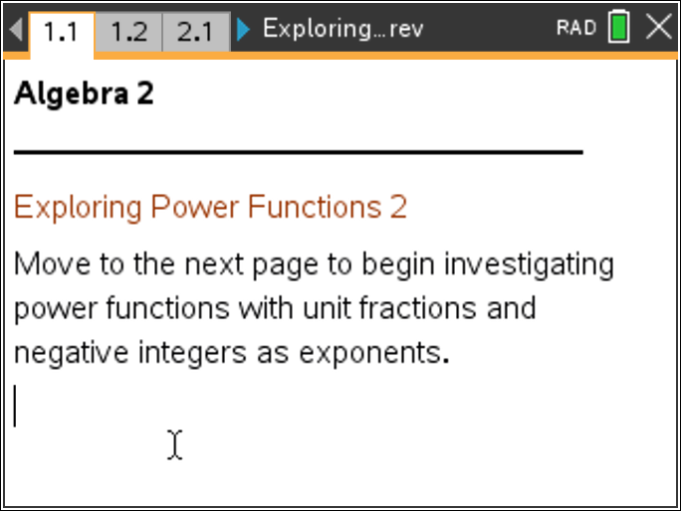

Move to page 1.2. | Press / ¢ and / ¡ to navigate through the lesson.
1. This page displays graphs of power functions with unit fractions as the exponent. Describe the shape of the graph of .

2. Compare the graph of an equation where the power has an even denominator to the graph of an equation where the power has an odd denominator. Why are the graphs different?

Move to page 2.1.

3. This page compares radical equations to power functions with unit fractions as exponents. Make a conjecture about a rule that relates power functions and radical functions. Click the slider to explore.

4. Why is the graph of displayed only in the first quadrant?

5. Compare the key information about power functions with even and odd unit fraction exponents by completing the table below:

p-value | Points on All Graphs | Function Domain | Function Range
Even
Odd

6. Click the slider until the denominator equals 1. Why does the graph resemble a line?

Move to page 3.1.

7. This page shows graphs of power functions with negative integer exponents. How is the graph of different from the graphs in previous questions?

8. Click the slider to change the value of the exponent. The graphs never connect. At which x-value is there a break? Why is the break at this x-value?

9. When the value of the exponent is negative, the graph always consists of two pieces. When the exponent is even, the two branches are in the first and second quadrants. When the exponent is odd, the two branches are in the first and third quadrants. Why do the graphs behave this way?

Move to page 4.1.

10. Compare the key information about power functions with negative integer exponents in the table below:

p-value | Points on All Graphs | Function Domain | Function Range
Evens
Odds

11. A rule for power functions with negative exponents is . How do the graphs on page 4.1 support this? Why does this rule work?

12. An asymptote is a line that a graph approaches but never reaches. The graphs of power functions with negative integer exponents have the x-axis and y-axis as asymptotes. Why do the graphs approach, but never reach, these lines?

Move to page 5.1.

13. This page shows power functions with integer exponents from –8 to 8. Click the slider until the exponent is 0. What is the equation when the exponent is 0, and what is the form of the graph? Why is there a hole at x = 0 on this graph? (Hint: Consider using the Scratchpad to do a calculation.)

