Topic 3: Geometry and Trigonometry | Trig Ratios
- A cat is stuck on the top of a building, D, which is on a horizontal street. Her worried owner, Kara, is standing on the street at a point O at an angle of depression of 60°. The base of the building is at G. The height of the building is 50 ft. The following diagram indicates the positions of D, O, and G. |  |  | 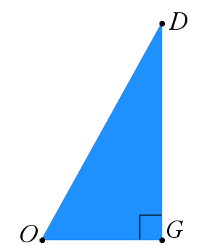
- Label, in the diagram, the values of  - The height of the building  - The angle of depression  - Find the distance Kara is from the base of the building  - Kara estimates that the distance from the base of the building to where she is standing is 40 ft. Calculate the percentage error of Kara’s estimate. |  |  |  | (1 mark)  (1 mark)  (2 marks)  (2 marks)
Mark scheme:  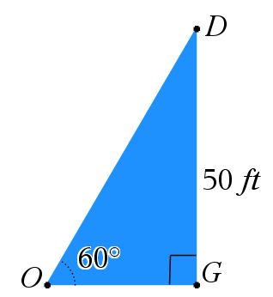 |  | (A1)  (A1)

- $\tan{60°=\frac{50}{x}}$  $x=28.9$ ft  - $\left|\frac{40-28.9}{28.9}\right|*100$  $$=38.4\%$$ | (M1)  (A1)  (M1)  (A1)

