In this activity, students will review their binomial expansion skills through hands on multiplication combined with the handheld to check their work. Close attention will be played to individual terms of certain expansions throughout the activity. The Binomial Theorem and Pascal’s Triangle will also be used as tools to aid in this process. | 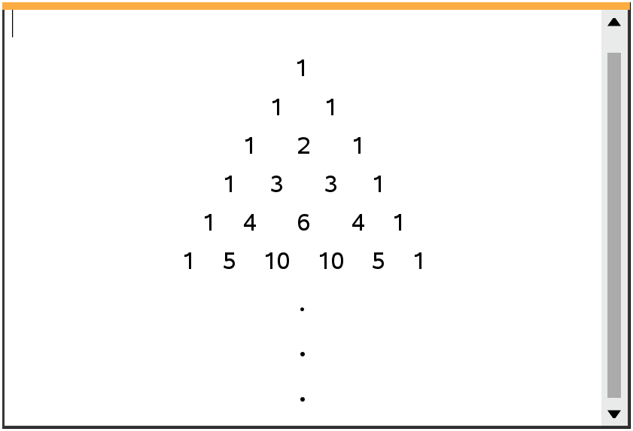
______________________________________________________________________________

What is binomial expansion? It is a method used that allows us to expand and simplify algebraic expressions in the form ${\left(a+b\right)}^{n}$, into the sum of one or more terms, where $n ∈ N$. For example:

$${\left(a+b\right)}^{3}= a^{3}+3a^{2}b+3ab^{2}+a^{3}$$

There are several ways to approach this expansion, those of which we will discuss throughout this activity. In addition to finding an entire expansion, we will find and use individual terms within certain expansions.

Problem 1 – The Basic Expansion

1. If the expansion of ${\left(a+b\right)}^{4}= a^{4}+4a^{3}b+6a^{2}b^{2}+4ab^{3}+ b^{4}$, discuss with a classmate at least two methods you would use to find this expansion. Write those methods here.

2. Discuss with a classmate any patterns you noticed from the expansion given in question 1. Write those patterns here.

3. Using the patterns and methods discussed in questions 1 and 2, find the expansion of ${\left(a+b\right)}^{5}$.

Problem 2 – Beyond the Basic Expansion

1. Discuss with a classmate what would change about your procedure from problem 1 if you were trying to find the expansion of ${\left(x+3\right)}^{3}$. Explain.

2. Find the expansion of ${\left(x+3\right)}^{3}$.

3. Discuss with a classmate what would change about your procedure from problem 1 if you were trying to find the expansion of ${\left(a-b\right)}^{4}$. Explain.

4. Find the expansion of ${\left(a-b\right)}^{4}$.

5. Discuss with a classmate what would change about your procedure from problem 1 if you were trying to find the expansion of ${\left(2x+3y\right)}^{3}.$ Explain.

6. Find the expansion of ${\left(2x+3y\right)}^{3}$.

Problem 3 – The Binomial Theorem

At times, it is unrealistic and time consuming to find the entire expansion. For example ${\left(a+b \right)}^{21}$ would take a class period to expand. This is where the binomial theorem comes into play. The binomial theorem allows you to find individual terms of an expansion. One of the ways that was hopefully discussed in Problem 1, was the use of Pascal’s Triangle. This triangular pattern of data displays each coefficient of any binomial expansion, no matter the degree of the binomial. Each row represents a new expansion, but this too can be time consuming. The binomial theorem uses the idea of combinations to help find these coefficients. The formula used to find individual terms in the binomial theorem is

$$_{n}C_{r} ∙ a^{n-r}∙b^{r}, where n=degree and r=one less than the term number and _{n}C_{r}= \frac{n!}{r!\left(n-r\right)!}$$

Let’s look at an example. If we were given the binomial ${\left(x+y\right)}^{6}$ and we wanted to find the 5th term of the expansion, here is what you would do:
$n=6 and r=4$, therefore $_{6}C_{4}∙ a^{6-4}∙b^{4}=15a^{2}b^{4}$
If you were to expand Pascal’s Triangle to the 6th degree row it would be:
1 6 15 20 15 6 1
Counting from left to right, the 5th term coefficient is 15, the same as the coefficient from the binomial theorem. Please note that the $r$ value is also the b exponent in this term.

1. Consider the binomial expansion ${\left(x-2\right)}^{8}= x^{8}+ax^{7}+bx^{6}-448x^{5}+…+256$, where $x ≠0$ and $a, b ∈ Z^{+}$
(a) Show that $b= 112$.

(b) The coefficient of the 6th term is the opposite of the coefficient of the 7th term. Find these two coefficients.

2. In the expansion of ${\left(x+p\right)}^{9}$, where $p ∈ R$, the coefficient of the term in $x^{7}$ is 576. Find the possible values of $p$.

3. Consider the expansion of ${\left({2x}^{2}+ \frac{m}{x}\right)}^{5}$, where $m>0$. The coefficient of the term in $x^{4}$ is $2880$. Find the value of $m$.

4. In the expansion of ${\left(5+ x^{2}\right)}^{n+1}$, where $n ∈ Z^{+}$. Given that the coefficient of $x^{6}$ is $1,312,000$, find the value of $n$.

Further IB Application

Consider the expansion of $\frac{{\left(b∙x-3\right)}^{12}}{15x^{3}}$, where $b≠0$. The coefficient of the term in $x^{8}$ is $-\frac{12}{5}b^{10}$. Find the value of $b$.

