Topic 4: Statistics and Probability | Five Number Summary
- The following box and whisker plot shows the number of text messages sent by Kevin and his co-workers in a typical work day.

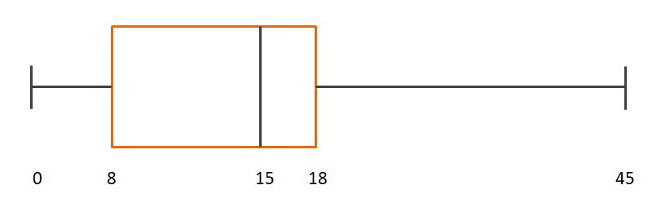
- Find the value of the interquartile range  - One worker sent $p$ messages, where $p>18$. Given $p$  is an outlier, find the least value of $p$. |  |  | (2 marks)  (4 marks)
Mark scheme:  - $Q_{3}-Q_{1}=18-8=10$  - IQR $*1.5+Q_{3}$  $$=\left(10\right)\left(1.5\right)+18 \\ =15+18 \\ =33 \\ p=33$$ |  | (M1)(A1)  (M1)  (A1)  (A1)  (A1)

