Open the TI-Nspire document Crossing_The_Asymptote.tns.  In this activity, you will explore the following question: If p(x) and q(x) are polynomials of degree 1 or 2, under what condition(s) does the graph of the rational function cross its horizontal asymptote? | 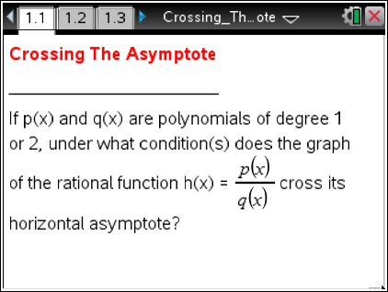

Recall that a rational function is the quotient of two polynomials. When the degree of the numerator is less than or equal to the degree of the denominator, a horizontal asymptote might exist. If the degree of the numerator equals the degree of the denominator, a horizontal asymptote exists at y = (ratio of leading coefficients of numerator and denominator); and if the degree of the numerator is less than that of the denominator, a horizontal asymptote exists at . For example, the horizontal asymptote (if it exists) of is , and the horizontal asymptote (if it exists) of is .

Move to page 1.2.
1. Consider an example where when both and are linear:
where .

Set the value of the slider b to –6. Then scroll through the values of slider a from –6 to 6, and make a note of the cases when the graph of crosses its asymptote . Ignore since we are only considering values of . Set b to –5, and scroll through the values of a noting any cases where the graph crosses its asymptote. Repeat this process for values of b from –6 to 6. What pairs of values (if any) for a and b did you note?

Move to page 1.3.
2. In general, make a conjecture about the sets of values (if any) of where the graph of the rational function crosses its horizontal asymptote . [Assume , and is not a multiple of .]

Move to page 1.4.
3. Test your conjecture. The functions and have been defined. Enter . Does this result validate your conjecture? Why or why not? If your conjecture was not correct, revise it so the resulting statement is correct.

Move to page 2.1.
4. Consider an example where when p(x) is linear and q(x)is quadratic:
; where.

Set the value of the slider b to –6. Then scroll through the values of slider a from –6 to 6, and make a note of the cases when the graph of crosses its asymptote, . Ignore a = 0 since we are only considering values of . Then set b to –5, and scroll through the values of noting any cases where the graph crosses its asymptote. Repeat this process for values of b from –6 to 6. Describe the pairs of values of a and b that you noted.

Move to page 2.2.
5. In general, make a conjecture about the sets of values where the graph of the rational function does not cross its horizontal asymptote. [Assume , and is not a multiple of ]

Move to page 2.3.
6. Test your conjecture. The functions and have been defined. Enter . Does this result validate your conjecture? Why or why not? If your conjecture was not correct, revise it so the resulting statement is correct.

Move to page 3.1.
7. Consider an example where when both p(x) and q(x) are quadratic:
; where .

a. Set the value of the slider b to –6. Then scroll through the values of slider a from –6 to 6, and enter the value of a (if one exists) when the graph of does not cross its asymptote, , in the table. Ignore a = 0 since we are only considering values of . Then set b to –5, and scroll through the values of a. Repeat this process for values of b from –6 to 6.

Hint: For a given value of b, there is at most one value of a for which the graph does not cross its asymptote.

b | –6 | –5 | –4 | –3 | –2 | –1 | 1 | 2 | 3 | 4 | 5 | 6
a

b. The boxes below –1 and 1 are blank. If the values of the sliders for a and b were not limited, what values would go in each of these two boxes?

c. Make a conjecture about the relationship between a and b that is true for the rational functions in this set whose graph does not cross its horizontal asymptote.

Move to page 3.2.
8. In general, make a conjecture about the relationship betweenif the graph of the rational function does not cross its horizontal asymptote. [Assume and and do not have a common linear factor.]

Move to page 3.3.
9. Test your conjecture. The functions and have been defined. Enter . Does this result validate your conjecture? Why or why not? If your conjecture was not correct, revise it so the resulting statement is correct.

